語言訓練測驗中心
英語能力分級檢定中級預試
口說能力測驗

試題別: OTI

請在15秒內完成並唸出下列自我介紹的句子，請開始：

My registration number is (准考證號碼) , and my seat number is (座位號碼) .

朗讀短文

請先利用1分鐘的時間閱讀下面的短文，然後在2分鐘內以正常的速度，清楚正確的朗讀下面的短文。

I am writing to you to say how much I love your program. I never miss it. It’s the most wonderful program that has ever been put on TV. Nearly all of my classmates watch it, and as for the people who don’t like it, I can’t see what there is to complain about. Most of the actors are outstanding. I think you should make it a long-running series.
* * *
Humor is important. Every speech needs it, and we need it too. Many professional speakers want a joke at the beginning of their speeches because they need the quick victory of laughter. It helps them relax. It also helps the audience relax.
* * *
According to the report from the Environmental Protection Administration (EPA), Taiwan generated about 8.9 million tons of garbage in 1997, an average of 24,000 tons a day. In fact, the amount of waste disposal in Taiwan has grown 6 percent per year over the last ten years. Taiwan is facing a garbage problem that is becoming more and more serious.

回答問題

這個部分共有10題。題目已事先錄音，每題經由耳機播出二次，不印在試題冊上。第1至5題，每題回答時間15秒；第6至10題，每題回答時間30秒。每題播出後，請立即回答。回答時，不一定要用完整的句子，但請在作答時間內儘量的表達。
OTI

看圖敘述

下面有一張圖片及四個相關的問題，請在1分半鐘內完成作答。作答時，請直接回答，不需將題號及題目唸出。

- Where are these children?
- What are they doing?
- Do you think they are enjoying themselves? What makes you think so?
- If you still have time, please describe the picture in as much detail as you can.

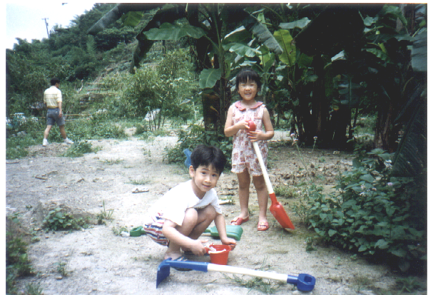

請將下列自我介紹的句子再唸一遍，請開始：

My registration number is (准考證號碼) , and my seat number is (座位號碼) .

